REPUBLIC OF INDIA
Ministry of Petroleum & Natural Gas · Ministry of Power · Ministry of Chemicals & Fertilizers

National Resource Recovery Grid
India (NRRG-India)

A National-Scale Integrated Waste-to-Resource Infrastructure Proposal

Submitted for Consideration · April 2026 · Independent Research Study

1. EXECUTIVE SUMMARY

India is the world's third-largest energy consumer, second-largest coal producer, largest urea producer, and one of the largest agricultural economies on the planet. Its four industrial ecosystems — petroleum refineries, thermal power plants, fertiliser and chemical plants, and agro-industrial processing — collectively generate waste streams of a scale unmatched outside China. Yet these systems operate in complete isolation from one another. The waste output of one ecosystem is not the resource input of the next. The heat lost from a thermal power plant 40 km from a distillery is not used to process that distillery's vinasse. The high-purity CO2 from an ammonia plant is not routed to the food-grade CO2 market 100 km away. The 92 million tonnes of crop residue burned every year in Punjab and Uttar Pradesh — generating 33,834 Gg of CO2-equivalent annually and causing an estimated 44,000 to 98,000 premature deaths per year — is not converted to biogas or electricity. It is burned, at zero return, as a disposal method.
The National Resource Recovery Grid (NRRG-India) is a hybrid multi-sector integration framework designed to connect these four ecosystems through shared infrastructure, intelligent resource routing, and coordinated regulatory incentives. NRRG-India does not require new industrial capacity. It captures what is already being generated and currently lost — across heat, carbon, water, biomass, and solid waste streams — and routes it to its highest-value use.

THE SYSTEM
NRRG-India targets deployment across five priority hub types: petroleum refinery corridors (Gujarat, Maharashtra), thermal power plant clusters (Chhattisgarh, UP, Jharkhand), fertiliser-agro integration zones (UP, Punjab, Haryana), coastal petrochemical-desalination nodes (Tamil Nadu, Andhra Pradesh), and biomass energy belts (sugarcane states). The five highest-impact interventions — in order of national value — are: (1) crop residue gasification replacing stubble burning, (2) fertiliser plant CO2 capture and utilisation, (3) thermal power waste heat recovery and water recycling, (4) petroleum refinery heat integration, and (5) fly ash comprehensive utilisation. Estimated combined national value at full scale: ₹ 2.8 to 4.2 trillion annually.

226 Mt/yr  Fly Ash Generated  83% utilised; 17% gap | 92–116 Mt/yr  Crop Residue Burned  120 TWh electricity potential | 45 Mt CO₂/yr  Fertiliser Plant CO₂  From ammonia synthesis alone | ₹2.8–4.2T  Annual Recovery Value  Full national deployment

2. STRATEGIC CONTEXT: THE FOUR-ECOSYSTEM PARADOX

India's industrial paradox is structural, not technical. The country generates more coal fly ash per unit of electricity than any major economy — Indian Gondwana coal carries 30 to 50% ash content against a global average of 10 to 15%, with a calorific value of 3,603 kcal/kg versus 6,000+ kcal/kg for premium coal. This means Indian thermal power plants generate approximately twice the waste solids per kilowatt-hour compared to Chinese or American plants running on higher-quality coal. Every tonne of Indian coal consumed produces more fly ash, more residual heat loss, and a lower net energy yield than coal used in competitor economies. The plants are not inefficient by design — they are inefficient by feedstock.
The fertiliser sector presents a different version of the same problem. India produces 31.2 million tonnes of urea annually, making it the world's largest urea producer. Urea synthesis requires both ammonia and CO2 as feedstocks — but the CO2 generated from the steam methane reforming process used to produce hydrogen for ammonia synthesis is currently treated as a byproduct emission rather than an industrial input. Every tonne of ammonia produced generates 1.6 tonnes of CO2, totalling approximately 45 million tonnes of CO2 per year from India's ammonia plants alone — most of which is either vented or used only partially in urea synthesis. The industrial CO2 market value of this stream at $50–150 per tonne represents ₹ 1.5 to 4.5 trillion per year in unrealised revenue.
The agricultural sector is the most visible failure. Ninety-two million tonnes of crop residue is burned in Indian fields every year — primarily in Punjab, Haryana, and Uttar Pradesh — because the alternative (mechanical collection, transport, and processing) has no financially viable destination for the biomass. NRRG-India creates that destination: cluster-scale biogas and biomass power installations that give farmers a price for their residue instead of a fine for burning it.
Alignment with National Policy Frameworks
Policy Framework | NRRG-India Contribution
National Action Plan on Climate Change (NAPCC): National Mission for Enhanced Energy Efficiency | Cross-sector waste heat recovery and industrial symbiosis directly advances energy efficiency targets across all four ecosystems
PM Gati Shakti: National Master Plan for Multi-Modal Connectivity | NRRG-India cluster hubs require and reinforce industrial corridor connectivity — Gujarat, Mumbai-Pune, Delhi-NCR, Chennai-Bangalore
National Green Hydrogen Mission: replace grey ammonia by 2034–35 | Fertiliser plant CO2 capture under NRRG-India produces the CO2 supply required for green urea synthesis using green ammonia — enabling the transition at lower system cost
CPCB Fly Ash Notification (amended 2021, 2022, 2024): 100% utilisation mandate | NRRG-India fly ash module operationalises the 100% utilisation mandate through geopolymer manufacturing, cement blending, and mine-fill logistics
Crop Residue Management Guidelines (2023–24 Revised): eliminate stubble burning by 2027 (Haryana), national NCAP targets | NRRG-India biomass module creates the economic infrastructure that makes stubble burning replacement financially viable for small and marginal farmers
RenovaBio equivalent — India Carbon Market (ICM) framework | CO2 capture, biogas, and fly ash utilisation modules generate carbon credits under India's developing carbon market framework

3. INPUT STREAM CHARACTERISATION: NATIONAL VOLUMES BY ECOSYSTEM

Ecosystem | Primary Waste Stream | National Annual Volume | Current Disposition | Recovery Potential
Thermal Power (229 GW coal capacity) | Fly ash; bottom ash; flue gas waste heat; cooling water loss | ~226 Mt fly ash/yr; ~1,259 gCO₂/kWh (national avg); cooling losses ~15–20% of input energy | 83% fly ash utilised (cement, construction); 17% landfilled; heat entirely wasted | VERY HIGH — 38 Mt unused fly ash; waste heat equivalent to ~40–60 GW thermal if captured at 10% efficiency
Fertiliser & Chemicals (31.2 Mt urea/yr) | High-purity CO2 from ammonia synthesis; waste heat from reformers | ~45 Mt CO₂/yr from ammonia; 1.6 t CO₂ per t NH3; ~17–19 MTPA ammonia for fertilisers | Partially consumed in urea synthesis; excess vented; heat lost to cooling | VERY HIGH — food/industrial CO2 at $80–350/t; partial CO2 already used in urea means infrastructure exists
Petroleum Refineries (Gujarat, Maharashtra, Tamil Nadu, UP) | Flare gas; waste heat (distillation columns, crackers); refinery wastewater; produced water | India refines ~250 million tonnes of crude/yr; flaring losses ~5–8% of throughput in older refineries | Modern refineries well-optimised; older plants (1970s–80s) have significant flaring and heat loss | MEDIUM-HIGH — flare gas recovery (methane, LPG); heat integration with nearby agro/chemical plants
Agro-Industrial (Sugar/Ethanol — 5,000+ mills) | Bagasse waste heat; vinasse/spent wash; fermentation CO2; press mud | ~350–400 Mt sugarcane crushed/yr; ~30–35 billion litres ethanol equivalent; vinasse ~10–12 L per L ethanol | Bagasse mostly burned for cogeneration; vinasse fertigated; CO2 vented | HIGH — same Brazil ATRIS logic applies; CO2 capture priority; biogas from vinasse
Crop Residue Burning (Punjab, Haryana, UP, MP) | Rice straw, wheat straw, sugarcane trash, maize stalks | 500–516 Mt generated/yr; 92–116 Mt burned; 120 TWh electricity potential if converted | ~24% burned in field; rest used as fodder, fuel, mulch; zero structured recovery | VERY HIGH — 44,000–98,000 premature deaths/yr from burning; 120 TWh power potential; biogas/gasification

4. SYSTEM ARCHITECTURE: THE NRRG-INDIA HYBRID MODEL

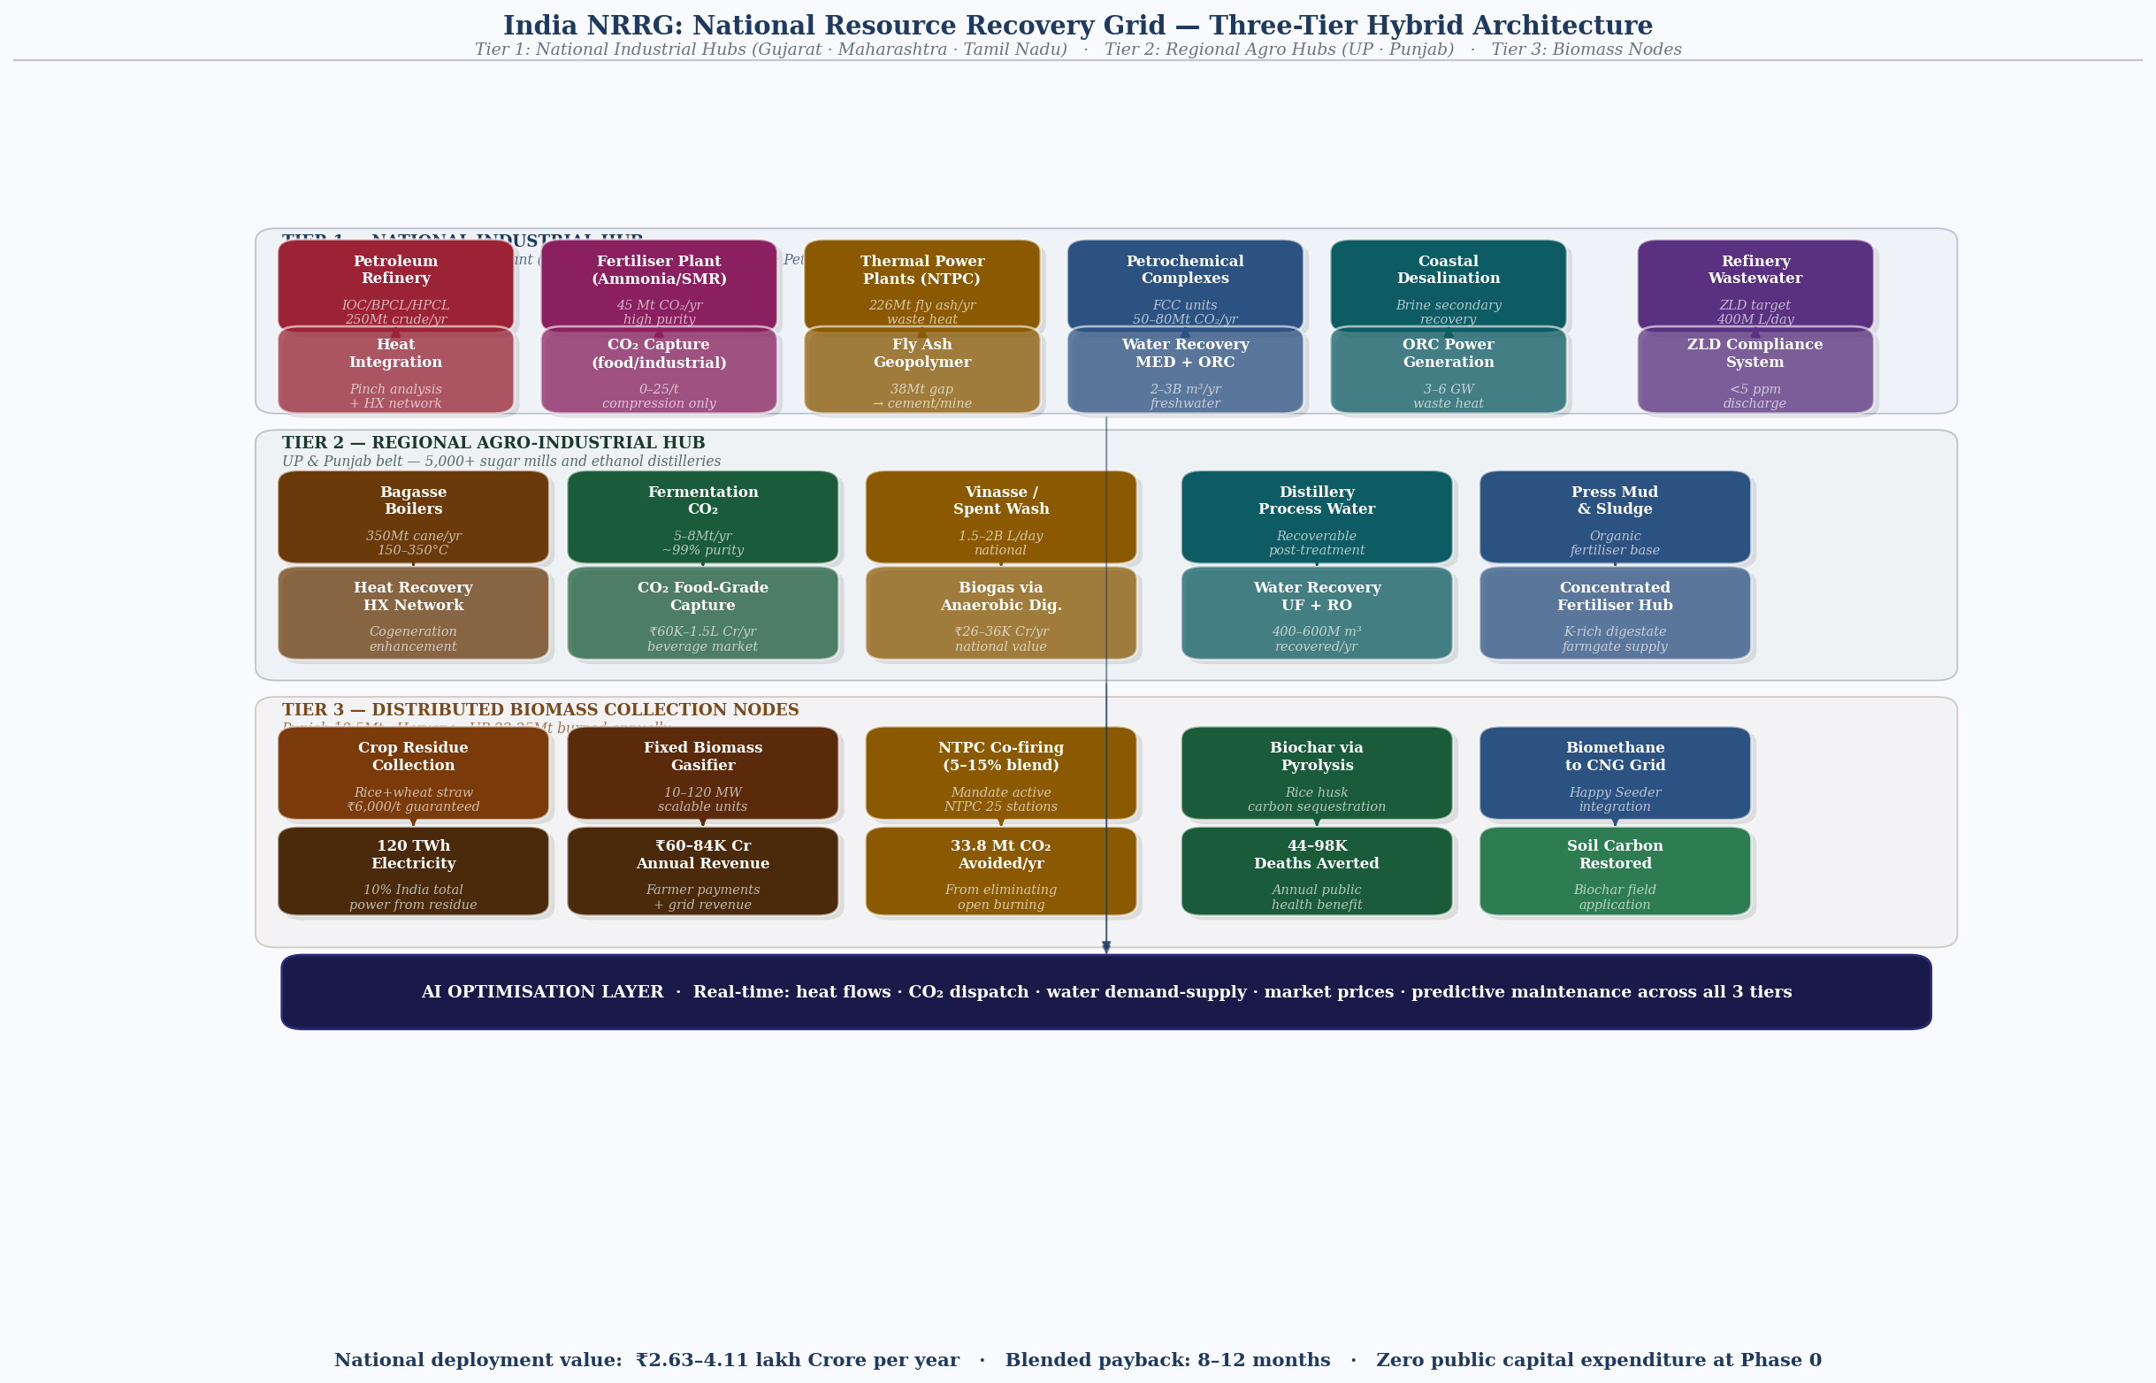
Fig. 1 NRRG-India three-tier hybrid architecture — Tier 1: National Industrial Hubs; Tier 2: Regional Agro-Industrial Hubs; Tier 3: Distributed Biomass Collection Nodes; AI optimisation layer connecting all three tiers in real time
India cannot use the Gulf model (centralized hub) or the Brazilian model (agro cluster) alone. Its industrial landscape requires a three-tier hybrid architecture that connects national-scale industrial hubs, regional agro-processing clusters, and distributed biomass collection nodes — linked by an AI-driven intelligence layer that optimises resource flows across all three.
4.1 Three-Tier Architecture
Tier | Node Type | Geography & Function
Tier 1: National Industrial Hub | Petroleum refinery + thermal power + fertiliser plant within 100 km radius | Gujarat (Jamnagar, Vadodara, Surat), Maharashtra (Mumbai-Pune corridor), Tamil Nadu (Chennai, Tuticorin), Uttar Pradesh (Mathura, Agra). Full-stack integration: waste heat exchange, CO2 capture, water recycling, fly ash logistics.
Tier 2: Regional Agro Hub | Sugar mill cluster + ethanol distillery + fertiliser demand zone | Uttar Pradesh (Gorakhpur, Lucknow belt), Punjab (Amritsar, Ludhiana), Maharashtra (Nashik, Kolhapur). Applies Brazil ATRIS model: CO2 capture, vinasse biogas, concentrated fertiliser, waste heat water recovery.
Tier 3: Biomass Collection Node | Distributed crop residue collection, compression, and gasification | Punjab (19.5 Mt residue managed in 2024), Haryana, UP (22.25 Mt burned). Mobile and fixed gasifiers; Happy Seeder integration; biochar and biogas output routed to Tier 1 and Tier 2 hubs.

4.2 Module-by-Module Design
Module 1: Heat Recovery Network
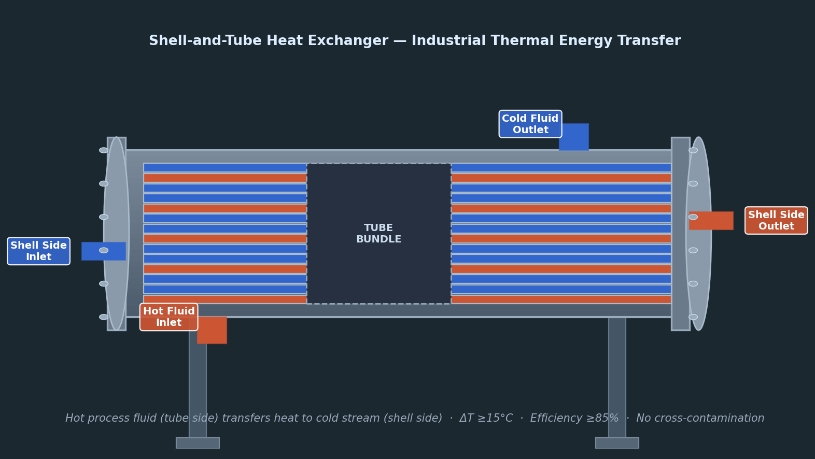
Fig. 2 Shell-and-tube heat exchanger — connects petroleum refinery distillation columns (150–400°C) to adjacent fertiliser plant reformers and water recovery systems via pinch analysis; efficiency >= 85%
Source | Temperature | Technology | Output | Priority
Coal power plant flue gas / condenser | 50–180°C | Organic Rankine Cycle (ORC); absorption chillers; low-grade heat exchangers | Electricity (ORC); process cooling; water distillation pre-heat | MEDIUM — ORC efficiency 8–15%; payback 4–6 years
Petroleum refinery distillation columns | 150–400°C | Shell-and-tube exchangers; heat integration pinch analysis; steam generation | High-grade steam for MED water recovery; process heat to adjacent fertiliser plants | HIGH — refinery heat integration already standard; extension to neighbours is incremental
Fertiliser plant reformers (SMR) | 800–900°C | Waste heat boilers; steam reforming heat recovery | Steam for power generation; high-grade heat for water distillation; pre-heat for CO2 compression | HIGH — high-grade heat; CO2 capture energy demand partially self-funded
Sugar mill bagasse boilers | 250–350°C | High-pressure boilers (already present); HRSG; vapour recompression | Electricity cogeneration (existing); additional heat for vinasse evaporation and water recovery | MEDIUM — infrastructure exists; integration with water recovery is incremental

Module 2: Water Recovery & Recycling System
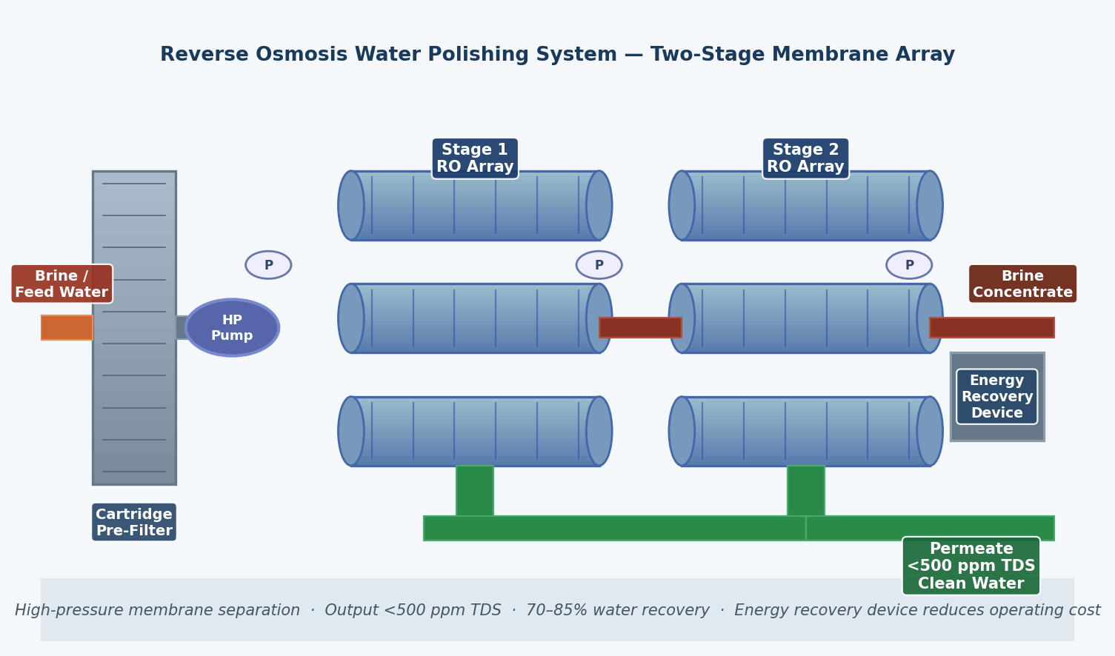
Fig. 3 Reverse osmosis water recovery system — two-stage membrane treatment of power plant cooling water blowdown, distillery spent wash, and refinery process water; national potential 2–3 billion m³/year freshwater saved
India faces acute industrial water stress. Thermal power plants are the largest industrial freshwater consumers in India, using 2–3 litres per kWh of electricity generated through once-through or cooling tower systems. Refineries, fertiliser plants, and distilleries compound this demand. NRRG-India's water module applies waste heat — most of which is already generated and discarded — to distillation-based recovery rather than purchasing new freshwater.
Input Stream | Recovery Method | Output Quality | National Volume Potential
Power plant cooling water blowdown | Filtration + softening + RO; waste heat for thermal distillation | Process water reuse; boiler feed water | ~2–3 billion m³/yr reduction in freshwater withdrawal if cooling systems optimised nationally
Distillery spent wash / vinasse | Anaerobic digestion; multi-effect evaporation using waste heat; membrane bioreactor | Industrial reuse after RO; biogas as byproduct | ~1.5–2 billion litres/day nationally from ~5,000 distilleries
Refinery wastewater (oily water, process effluent) | API separator; DAF; advanced oxidation; RO polishing | Industrial reuse; cooling water makeup | ~200–400 million litres/day from refineries; current ZLD compliance varies widely
Fertiliser plant process water | Condensate recovery; steam stripping; membrane treatment | Boiler feed; process reuse | ~100–150 million litres/day; high value due to mineral content

Module 3: CO₂ Capture & Utilisation Layer
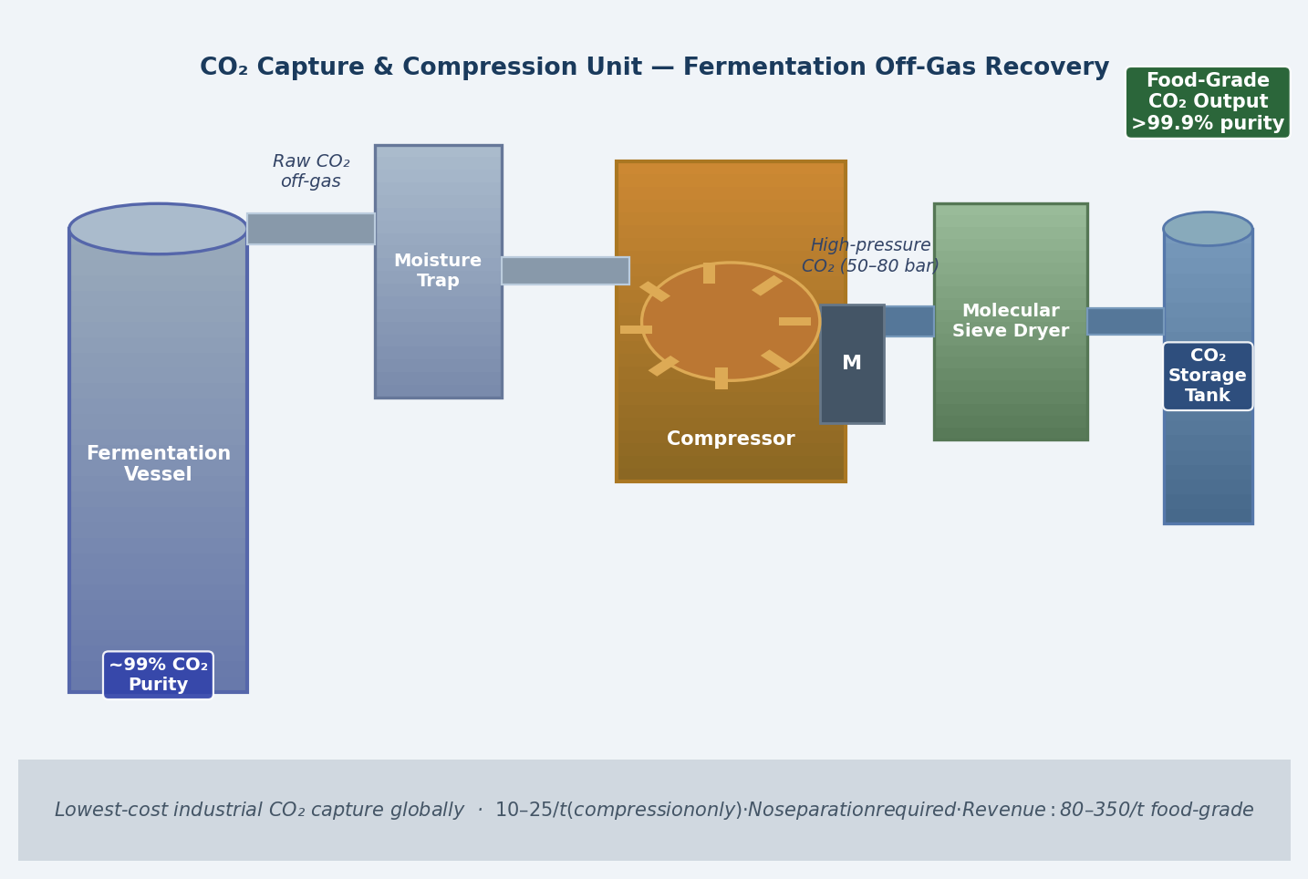
Fig. 4 CO₂ capture and compression unit at fertiliser plant — ammonia synthesis off-gas (95–99% purity) captured at $10–25/t; highest-ROI module in NRRG-India at 2–4 month payback; market value $80–350/t
India's CO2 capture opportunity is structurally differentiated: fertiliser plants generate high-purity CO2 (from ammonia synthesis) that requires minimal separation, while thermal power plants generate low-purity CO2 (flue gas, 12–14% CO2 concentration) that requires post-combustion capture. The two streams have very different economics and technology requirements.
CO₂ Source | Purity | Capture Cost | Best Utilisation Route | National Volume
Ammonia / urea plants (SMR process off-gas) | 95–99% — near-food-grade without additional separation | $10–25/t (compression + drying only) | Food/beverage CO2; industrial gases; green urea synthesis feedstock (with green NH3) | ~45 Mt/yr from ammonia synthesis
Ethanol fermentation (sugar/grain mills) | ~99% — identical to Brazil; biogenic | $15–30/t | Food-grade CO2; beverage carbonation; BECCS credits | ~5–8 Mt/yr from 5,000+ distilleries
Thermal power plant flue gas | 12–14% — low purity; requires post-combustion capture | $40–80/t (amine scrubbing or solid sorbent) | Enhanced coal recovery; synthetic fuels (long-term); geological storage | ~1,000+ Mt/yr — enormous volume; high capture cost limits near-term economics
Refinery process emissions (FCC units, reformers) | 15–25% — medium purity | $25–50/t | Industrial CO2; chemicals feedstock; enhanced oil recovery (Rajasthan, Gujarat oilfields) | ~50–80 Mt/yr from refineries

Module 4: Biomass Conversion Layer — The Stubble Problem
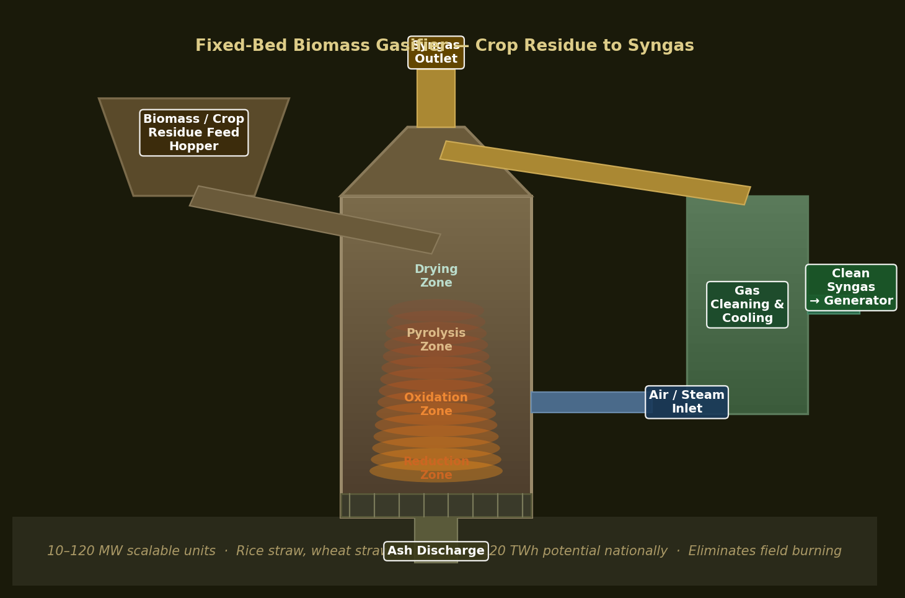
Fig. 5 Fixed-bed biomass gasifier — crop residue (rice straw, wheat straw) through four-zone reactor (drying, pyrolysis, oxidation, reduction); clean syngas to 10–120 MW generators; eliminates 33.8 Mt CO₂eq/yr from field burning
The crop residue burning problem in India is not a behavioural problem. It is a logistics and economics problem. Farmers burn because: (1) collection costs money they don't have, (2) there is no guaranteed buyer for collected residue, and (3) the fine for burning is lower than the cost of not burning. NRRG-India resolves all three by creating guaranteed offtake infrastructure within 50 km of every major burning cluster in Punjab, Haryana, and UP.
Conversion Pathway | Input Feedstock | Output | Economics
Biomass gasification + power | Rice straw, wheat straw (compressed into pellets or bales) | Electricity (120 TWh potential — 10% of India's total); syngas for industrial heat | ₹ 4–5/kWh production cost; sold at ₹ 5–7/kWh; farmer paid ₹ 5,500–7,000/t residue
Anaerobic digestion (biogas) | Rice straw (pre-treated), press mud, organic fraction | Biogas (55–65% CH4); compressed biomethane for grid injection or transport fuel | Compressed biomethane: ₹ 45–65/kg; replaces CNG at comparable price; viable with 10t+ /day feedstock
Biochar (pyrolysis) | Any dry biomass; rice husk particularly suitable | Biochar (soil amendment — sequesters carbon, improves yield); syngas as by-product | Biochar value: ₹ 8,000–20,000/t in premium agricultural markets; carbon credit eligible
Direct co-firing (NTPC mandate) | Crop residue pellets mixed 5–10% with coal | Electricity from existing thermal plants; no new infrastructure | NTPC has mandate to co-fire; farmer payment of ₹ 5,500/t already established; lowest-capex pathway

Module 5: Fly Ash Comprehensive Utilisation
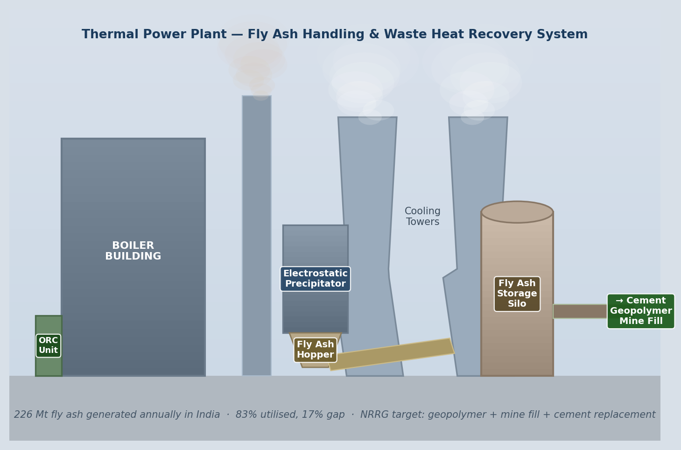
Fig. 6 Thermal power plant fly ash handling system — electrostatic precipitator captures fly ash; conveyor to storage silo; 38 Mt/year utilisation gap via geopolymer concrete, mine fill, and cement blending
India generates 226 million tonnes of fly ash per year. The 83% utilisation figure is misleading — it includes ash used to raise the walls of ash ponds (not a productive use) and ash used as road sub-base at very low value. True productive utilisation (cement replacement, high-grade geopolymer, mine fill) is significantly lower. NRRG-India targets the 17% gap plus the upgrade of low-value utilisation to high-value applications.
Utilisation Route | Volume Addressable | Value | Status
Portland cement replacement (up to 30% fly ash content) | 60–80 Mt/yr (current dominant use; expandable) | ₹ 1,500–2,500/t as cement substitute; reduces cement production emissions by 15–20% | Established — mandate exists; logistics gap in remote plants
Geopolymer concrete (high-value, no cement) | 5–10 Mt/yr (growing) | ₹ 3,000–5,000/t; higher strength, lower CO2 vs OPC | Emerging — commercial projects in Maharashtra, Telangana
Mine fill (abandoned coal mine voids in Jharkhand, Odisha, MP) | 30–40 Mt/yr potential | Disposal cost avoidance + land stabilisation; ₹ 500–800/t logistics cost | Policy framework exists (2021 Ash Notification); execution patchy
Agricultural amendment (silica, calcium, micronutrients) | 5–10 Mt/yr addressable | ₹ 800–1,200/t near plants; reduces chemical fertiliser use in acidic soils | Proven agronomically; regulatory approval under CPCB; limited adoption
Iron and alumina recovery (metallurgical) | 1–3 Mt/yr (high-Fe ash streams) | ₹ 15,000–40,000/t for recovered metal oxides | Pilot scale; technology mature in China; India implementation early stage

5. MASS & ENERGY FLOW MAPPING

The following table maps input to output across all five modules at national scale. All figures are based on verified 2024 data for India's industrial production.

Input Stream | Current Loss (baseline) | NRRG Recovery Output | National Annual Value | Module
226 Mt fly ash | 38 Mt landfilled; 188 Mt low-value use | 38 Mt → geopolymer, cement, mine-fill; 30 Mt upgraded to higher-value use | ₹ 57,000–95,000 Cr/yr from gap + upgrade | Module 5
92–116 Mt crop residue burned | 33,834 Gg CO₂eq/yr emitted; 44–98K premature deaths/yr; soil nutrient destruction | 120 TWh electricity; 40–60 Mt biogas feedstock; biochar from rice husk | ₹ 60,000–84,000 Cr/yr electricity; + health cost avoidance $3.2B/yr (Punjab alone) | Module 4
45 Mt CO₂ from fertiliser plants | Partially used in urea; excess vented | 10–15 Mt food/industrial CO2; 30+ Mt geological storage or green urea synthesis | ₹ 60,000–1,50,000 Cr/yr at $80–350/t food CO2 | Module 3
Thermal power waste heat (~40–60 GW thermal equivalent) | Entirely lost to atmosphere through cooling towers and flue gas | ORC electricity (~3–6 GW at 8–12% efficiency); 5–8 billion m³/yr water recovery via thermal distillation | ₹ 15,000–30,000 Cr/yr electricity; ₹ 25,000–40,000 Cr/yr water value | Module 1+2
Distillery spent wash / vinasse (5,000+ plants) | Fertigated via open channel; environmental liability | ~600–800 million m³/yr biogas feedstock; 400–600 million m³/yr recovered water | ₹ 18,000–24,000 Cr/yr biomethane; ₹ 8,000–12,000 Cr/yr water | Module 2+4

6. ECONOMIC MODEL

6.1 Revenue by Module at Full National Deployment
Module | CAPEX Estimate | Annual Revenue | Simple Payback
Module 3: Fertiliser CO2 capture (10 Mt food/industrial grade) | ₹ 8,000–15,000 Cr | ₹ 60,000–1,50,000 Cr/yr | 2–4 months — highest ROI in the system
Module 4: Crop residue gasification + NTPC co-firing (50 Mt/yr) | ₹ 25,000–40,000 Cr | ₹ 27,500 Cr/yr (₹ 5,500/t × 50 Mt) farmer payments alone; ₹ 60,000 Cr/yr electricity | 6–12 months
Module 5: Fly ash gap closure + upgrade (38 Mt gap + 30 Mt upgrade) | ₹ 12,000–20,000 Cr | ₹ 57,000–95,000 Cr/yr | 3–6 months
Module 1+2: Power plant waste heat + water recovery | ₹ 40,000–70,000 Cr | ₹ 40,000–70,000 Cr/yr | 12–18 months
Module 2: Distillery spent wash biogas + water | ₹ 15,000–25,000 Cr | ₹ 26,000–36,000 Cr/yr | 8–14 months
TOTAL NATIONAL SYSTEM | ₹ 1,00,000–1,70,000 Cr | ₹ 2,63,000–4,11,000 Cr/yr | ~8–12 months blended

7. HIGHEST IMPACT INTERVENTIONS: TOP 5 PRIORITY RANKING

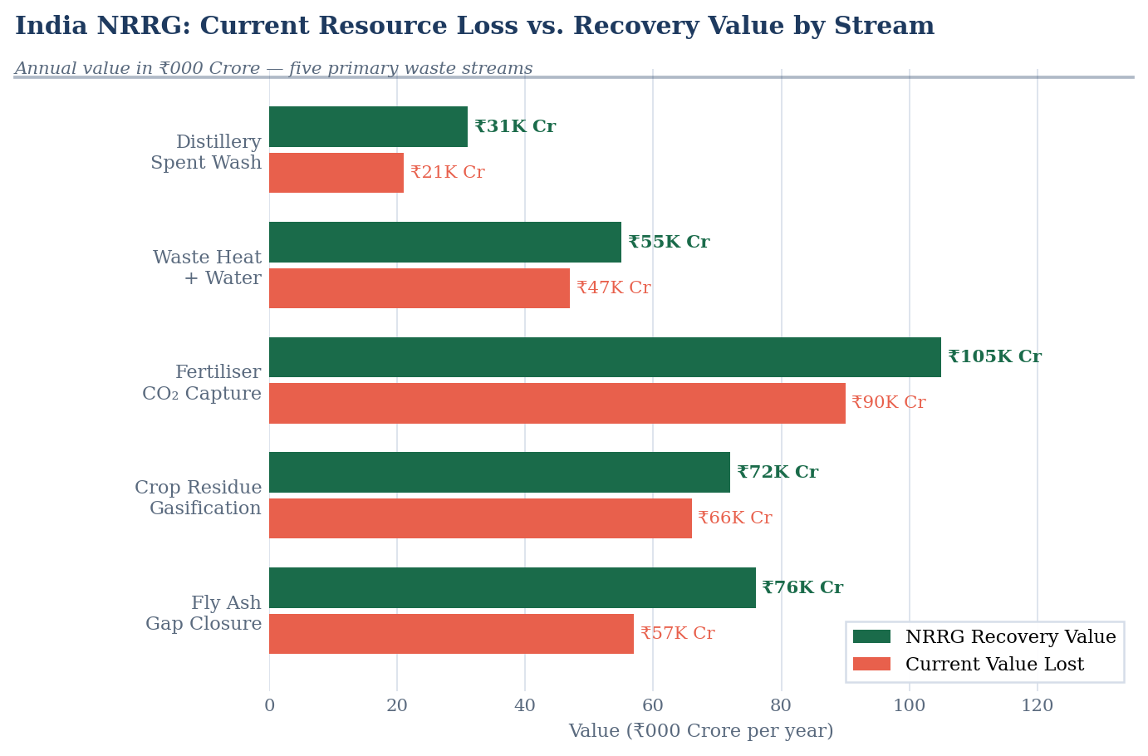
Fig. 7 Current resource loss vs. NRRG recovery value — five primary waste streams in ₹000 Crore/year: current value lost (red) vs. NRRG full-deployment recovery value (green)
Not all modules are equal. The following ranking reflects ROI, scale, urgency, political co-benefit, and technical readiness — the combination of factors that determines where NRRG-India should deploy first.

Rank | Intervention | CAPEX | Annual Value | Payback | Additional Benefit
1 | Fertiliser plant CO2 capture (food/industrial grade, 10 Mt target) | ₹ 8,000–15,000 Cr | ₹ 60,000–1,50,000 Cr/yr | 2–4 months | Infrastructure for green urea transition; reduces industrial CO2 venting; food security alignment
2 | Crop residue gasification replacing stubble burning (50 Mt/yr target) | ₹ 25,000–40,000 Cr | ₹ 60,000–84,000 Cr/yr electricity + farmer payments | 6–12 months | 44–98K premature deaths averted annually; Delhi air quality; Punjab farmer income; NTPC mandate alignment
3 | Fly ash gap closure: 38 Mt unused → geopolymer + cement + mine-fill | ₹ 12,000–20,000 Cr | ₹ 57,000–95,000 Cr/yr | 3–6 months | CPCB mandate compliance; 100% landfill elimination; construction cost reduction
4 | Thermal power waste heat → water recovery (MED + ORC at 50 major plants) | ₹ 40,000–70,000 Cr | ₹ 40,000–70,000 Cr/yr | 12–18 months | Industrial water security; reduces freshwater withdrawal by 2–3 billion m³/yr; enables power plant siting flexibility
5 | Distillery spent wash biogas + water recovery (5,000 plants nationwide) | ₹ 15,000–25,000 Cr | ₹ 26,000–36,000 Cr/yr | 8–14 months | Eliminates open-channel vinasse discharge; biomethane for CNG replacement; aligned with National Biogas Programme

Intervention 1 (fertiliser CO2) is the single most commercially attractive action in the entire NRRG-India system. It requires only compression and drying infrastructure at plants that already generate the CO2 as a process output. The capital cost is low, the payback is measured in months, and it directly enables the green urea transition that India's National Green Hydrogen Mission requires — by creating the CO2 supply infrastructure that green ammonia-based urea synthesis will need.

8. CLUSTER-BASED DEPLOYMENT STRATEGY

Priority Hub | States | Industrial Anchor | Primary NRRG Modules
Gujarat Industrial Corridor (Tier 1) | Gujarat | Jamnagar (Reliance — world's largest refinery complex), ONGC, GSPC, GNFC (fertilisers), Gujarat NRE Coke | Modules 1,2,3: refinery heat integration; fertiliser CO2 capture; coastal water recovery; fly ash from nearby GSECL plants
UP Fertiliser-Agro Belt (Tier 2) | Uttar Pradesh | NFL Shahjahanpur, IFFCO Phulpur, Paradeep Phosphates Kanpur; 860+ sugar mills; 22.25 Mt crop residue burned | Modules 3,4,5: fertiliser CO2; crop residue gasification (highest burning state); vinasse biogas; fly ash from UPRVUNL plants
Punjab-Haryana Biomass Belt (Tier 3) | Punjab, Haryana | 19.5 Mt residue managed in 2024 Punjab alone; Haryana target eliminate burning by 2027; NTPC Nabinagar, Bathinda refinery | Module 4 priority: Rice straw gasification; Happy Seeder integration; biochar; NTPC co-firing at Bathinda
Mumbai-Pune Chemical Corridor (Tier 1) | Maharashtra | BPCL Mumbai refinery; HPCL Mumbai; Tata Chemicals Mithapur; RCF Mumbai; ONGC Mumbai offshore | Modules 1,2,3: refinery-chemical cross-heat integration; industrial CO2 network; coastal water recovery (Arabian Sea intake avoided)
Chhattisgarh-Jharkhand Power Belt (Tier 1) | Chhattisgarh, Jharkhand, Odisha | NTPC Korba (2,600 MW), CSPGCL plants; highest fly ash generating states; Steel Authority of India (SAIL) blast furnace slag | Module 5 priority: fly ash geopolymer; mine fill in abandoned coal voids; ORC waste heat recovery; SAIL slag CO2 capture
Tamil Nadu Coastal Node (Tier 1) | Tamil Nadu | Chennai Petroleum (CPCL), SPIC fertilisers Tuticorin, TANGEDCO Mettur thermal plant; coastal location | Modules 1,2,3: fertiliser CO2 (SPIC); coastal water recovery (seawater desalination avoided); refinery-fertiliser heat integration

9. COMPARISON WITH GULF AND BRAZIL MODELS

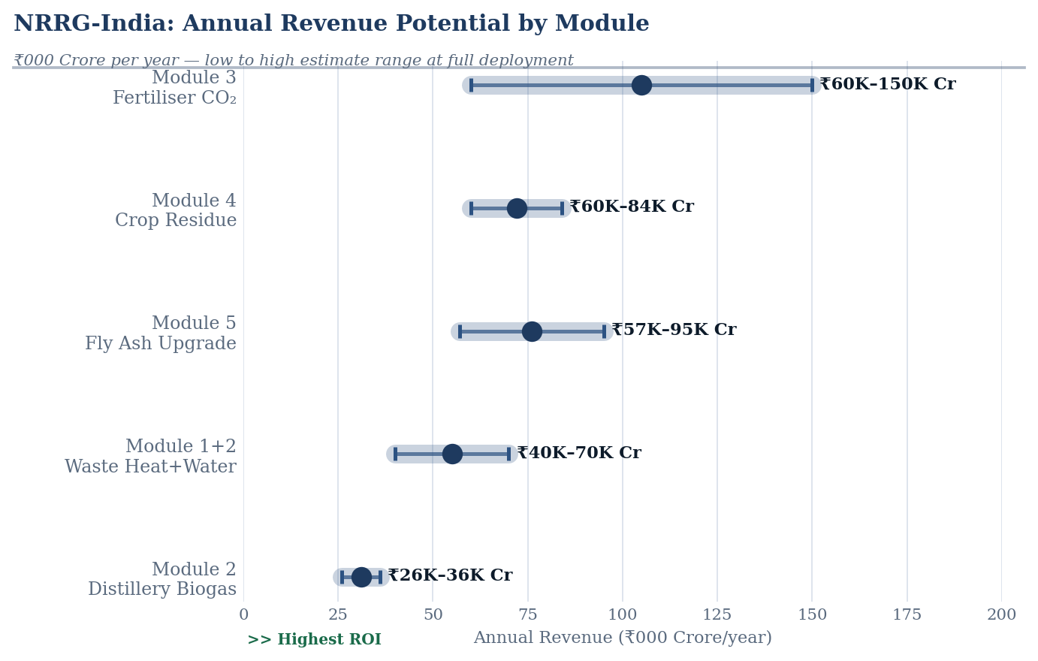
Fig. 8 NRRG annual revenue potential by module — low-to-high estimate range at full deployment; Module 3 (fertiliser CO₂) leads at ₹60,000–1,50,000 Crore/yr; Module 4 (crop residue) ₹60,000–84,000 Crore/yr
Dimension | Gulf (Bahrain/KSA/Kuwait) | Brazil (ATRIS) | India (NRRG)
Core industrial base | Petrochemical — oil refining, aluminium, desalination | Agro-industrial — sugarcane ethanol, biomass cogeneration | Hybrid — petroleum, thermal power, fertilisers, agro-industrial simultaneously
Primary waste streams | Waste heat (high-grade, 150–400°C); desalination brine; flue gas moisture | Fermentation CO2 (99% pure); vinasse; bagasse waste heat (80–350°C) | Fly ash (226 Mt/yr); crop residue (92–116 Mt burned); fertiliser CO2 (45 Mt/yr); power plant heat loss
Architecture | Centralised thermal hub — geographic concentration enables single-site aggregation | Cluster-based agro hubs — 2,000 km belt requires regional aggregation of 3–7 mills | Three-tier hybrid — Tier 1 industrial hubs + Tier 2 agro clusters + Tier 3 distributed biomass nodes
Primary recovery output | Water (industrial and near-potable) — national scarcity driver | CO2 (highest ROI); biogas (second); water (third) | CO2 (fertiliser plants, highest ROI) + electricity (crop residue) + fly ash materials (volume)
Carbon dimension | Carbon-intensive; recovery reduces fossil carbon footprint | Biogenic CO2; net-zero feedstock; BECCS creates negative emissions | Mixed: biogenic CO2 from ethanol (net-zero); fossil CO2 from power plants (sequestration needed); crop residue replacement (immediate health and emissions benefit)
Policy driver | Water security — national existential priority | RenovaBio + voluntary carbon market — commercial incentive | Multiple simultaneous: CPCB fly ash mandate; NCAP air quality; National Green Hydrogen Mission; crop residue guidelines
Payback period | 6–19 years (high capex, large-scale water infrastructure) | 3–18 months per module (low capex, high-value CO2 and biogas streams) | 2–18 months per module; blended 8–12 months; fertiliser CO2 is 2–4 months
Core principle | Identical: recover what is already being generated and currently lost | Identical | Identical

10. RISK REGISTER

Risk | Likelihood | Impact | Mitigation
Multi-ministry coordination: NRRG-India spans at least 6 ministries (Petroleum, Power, Chemicals, Agriculture, Environment, Railways for logistics) | High | High | Establish NRRG-India Mission as a cross-ministerial body under PMO (precedent: PM GatiShakti); single point of accountability; pilot clusters designed within single-ministry jurisdiction first
Feedstock payment to farmers: crop residue collection requires guaranteed prices; farmer trust in payment systems is low | High | High | Integrate with PM-KISAN payment infrastructure; direct bank transfer at collection point; NTPC co-firing mandate already establishes ₹ 5,500/t price signal; use Custom Hiring Centres as aggregation points
CO2 market development: food-grade CO2 market in India is nascent; large volume capture may depress prices | Medium | Medium | Phase deployment — begin with 2–3 Mt capture into established beverage/food market before expanding; develop industrial-scale utilisation (green urea, EOR) in parallel; export to Southeast Asian CO2 deficit markets
Fly ash logistics: plants in remote Chhattisgarh and Jharkhand are far from construction demand centres | High | Medium | Mine fill at adjacent abandoned mines reduces transport requirement; Indian Railways dedicated ash wagons (existing scheme); co-locate geopolymer manufacturing at plant boundary — eliminates transport
Technology integration risk: four ecosystem types with different operators, DCS systems, and technical standards | Medium | Medium | Modular API-based intelligence layer; each module independently operational; NRRG-India grid connects modules over time, not simultaneously; pilot with highest-ROI module (fertiliser CO2) first
Regulatory fragmentation: CPCB, CEA, MOEFCC, state PCBs each have jurisdiction over different waste streams | High | Medium | Single environmental clearance for designated NRRG-India cluster zones; precedent under PM GatiShakti for integrated industrial corridor approvals

11. GOVERNANCE & INSTITUTIONAL FRAMEWORK

Stakeholder | Role | Engagement
PMO / NITI Aayog | Cross-ministerial mandate; NRRG-India Mission charter; investment facilitation | Mission mandate under PM GatiShakti or standalone NRRG-India Mission; include in next 5-year plan
Ministry of Petroleum & Natural Gas | Refinery integration; ONGC coordination; flare gas recovery regulation | Refinery heat and CO2 integration standards; mandatory ZLD for refineries with NRRG-India modules
Ministry of Power / CEA / NTPC | Thermal power waste heat; fly ash logistics; NTPC co-firing mandate implementation | NTPC as anchor off-taker for crop residue; CEA standards for ORC and waste heat integration; fly ash notification enforcement
Ministry of Chemicals & Fertilizers | Fertiliser plant CO2 capture mandate; green urea transition roadmap | Mandate CO2 capture at all plants >500 kt/yr urea capacity; integrate with National Green Hydrogen Mission CO2 supply
Ministry of Agriculture / State Govts (Punjab, Haryana, UP) | Crop residue collection; farmer payment; Happy Seeder subsidy; Custom Hiring Centres | State-level MoUs for crop residue purchase guarantee; integrate with PM-KISAN payment system; extend Custom Hiring Centre subsidies to include biomass collection equipment
CPCB / MoEFCC | Environmental clearance; fly ash notification enforcement; CO2 utilisation classification | Single-window clearance for NRRG-India designated cluster zones; publish CO2 utilisation as 'recovered resource' not 'emission'
IOCL, BPCL, HPCL, ONGC (PSU anchor operators) | Provide access to refinery waste streams; co-invest in heat integration; CO2 offtake | Commercial MoUs for waste stream access; PSU co-investment in Tier 1 hubs; first-mover advantage in green product markets
Sagar-Raja (Private Operator) | 100% CAPEX for cluster infrastructure; design, build, operate, transfer | BOOT concession; 25-year operating license; performance bond; PSU partnership for anchor volume guarantee

12. RECOMMENDATION & REQUESTED ACTIONS

We respectfully request consideration of the following specific actions to initiate the NRRG-India programme:

1. | NRRG-India Mission Charter | Establish NRRG-India as a cross-ministerial mission under PM GatiShakti with a single designated Mission Director; mandate first pilot cluster in Gujarat (refinery + fertiliser CO2 + fly ash) within 12 months
2. | Fertiliser CO2 capture mandate | Require all urea plants >500 kt/yr capacity (approximately 20 plants, covering ~70% of national production) to install CO2 capture and utilisation systems within 36 months; establish CO2 offtake price guarantee through Food Corporation of India for food-grade CO2
3. | Crop residue guaranteed offtake | Establish NRRG-India Biomass Price Support Scheme — guaranteed ₹ 6,000/t for crop residue delivered to designated collection points in Punjab, Haryana, UP; fund through health cost avoidance savings (estimated $3.2B/yr Punjab alone)
4. | NTPC co-firing expansion | Scale NTPC crop residue co-firing from pilot to 15% blend at all 25 major NTPC stations by 2027; each station requires ~200,000 t/yr crop residue — creating a guaranteed off-take of 5 Mt/yr at launch scale
5. | Fly ash geopolymer industrial cluster | Co-locate geopolymer manufacturing units at 10 highest-generation fly ash plants (Korba, Vindhyachal, Ramagundam, Simhadri, Rihand, Farakka, Talcher, Chandrapura, Hasdeo, Sipat); each unit absorbs 1–3 Mt/yr at the plant gate; eliminates transport barrier
6. | NRRG-India Development Finance | Establish a ₹ 50,000 Cr NRRG-India Green Infrastructure Fund under RBI's priority sector lending framework; target 70% debt, 30% equity structure; allow green bond issuance against NRRG-India project cashflows

This proposal is presented as an independent research initiative. No public capital expenditure is required at Phase 0. Each module is commercially viable independently — NRRG-India is not a single monolithic investment but a connected system of individually profitable infrastructure decisions.

India is not resource-poor. It is a highly resource-generating system with low recovery efficiency. The resources are already being produced. The waste streams are already flowing. The losses are already occurring. NRRG-India changes what happens to them next.

DATA SOURCES & REFERENCES

The following primary sources inform the data presented in this proposal:
- MDPI Minerals: Status of Coal-Based Thermal Power Plants, Coal Fly Ash Production and Utilization in India (Nov 2022): fly ash generation and utilisation rates; 226 Mt/yr generation; 83% utilisation headline figure; state-wise distribution
- CSE India: India's Thermal Power Ash Mismanagement — An Ashen Legacy: state-wise ash utilisation gaps; litigation data; CPCB notification history; Chhattisgarh, UP, West Bengal as primary generating states
- CEEW: Economic Feasibility of Green Ammonia in India's Fertiliser Sector (May 2025): ammonia demand 17–19 MTPA; 25 Mt CO2eq from fertiliser production; green ammonia cost and transition pathway
- Nature Communications Sustainability: Green Ammonia for India's Food and Fuel Systems (Jan 2026): 45 Mt CO2/yr from nitrogen fertiliser synthesis; urea = 79% of nitrogen fertilisers; $17B annual urea subsidy
- Ammonia Energy / iFOREST: Green Urea — Economic and Environmental Benefits (Jul 2024): 31.2 Mt urea production; CO2 plant proximity map for urea production; Nagarjuna (AM Green) 1 MTPA renewable ammonia FID
- PMC / Crop Residue Burning in India — Policy Challenges (2019): 500 Mt crop residue generated; 92 Mt burned; Punjab, Haryana, UP primary states; 140 Mt surplus; biogas potential from rice straw
- Nature Communications: Air Quality Impacts of Crop Residue Burning in India (Nov 2022): 44,000–98,000 premature deaths/yr from agricultural burning; 67–90% from Punjab, Haryana, UP; $3.2B/yr health cost avoidance value (Punjab alone)
- ScienceDirect: Greenhouse Gas Emissions from Agricultural Residue Burning — Increased 75% Since 2011 (Sep 2023): 33,834 Gg CO2eq/yr in 2020 (up from 19,340 in 2011); Punjab 41% of national burned area; rice and wheat straw dominant
- ScienceDirect: Emissions of Air Pollutants from Crop Residue Burning in India: 120 TWh electricity potential from crop residue conversion (10% of India's total electricity); 488 Mt residue in 2017
- MDPI Energies: Crop Residue Management in India — Stubble Burning vs. Bioenergy (Jul 2021): 516 Mt residue in 2017–18; 116 Mt burned; 176 Mt CO2 generated from burning; co-firing and gasification pathway economics
- Current Agriculture Research Journal: Stubble Burning in India — Environmental Concern and Alternative Tools: NTPC co-firing mandate; ₹ 5,500/t farmer payment; Punjab 2024 crop residue management targets (19.5 Mt)
- ScienceDirect: Environmental Impacts of Indian Coal Thermal Power Plants: Gondwana coal 30–50% ash content; 3,603 kcal/kg average calorific value; 1,259 gCO2/kWh national coal emission intensity
- International Journal of Coal Preparation and Utilization: Comprehensive Review of India's Coal Landscape and Fly Ash (Nov 2024): CFA properties; utilisation pathways in construction, agriculture, wastewater; geopolymer applications
- Green Ammonia / Paradeep Phosphates: Green Ammonia for India's Fertiliser Sector: 1.6 t CO2 per t NH3 from SMR; 25 MTPA ammonia demand in 2023 growing to 45 MTPA by 2050; grey ammonia dominance
- IFA Short-Term Fertilizer Outlook 2024–25: 1.3 Mt N green ammonia projects by end-2025; 5.3 Mt N prospective by 2028; India capacity additions in phosphate

Prepared as an Independent Research Study · April 2026
Sagar-Raja · Abu Dhabi Global Market (ADGM), UAE
This study is unsolicited and not submitted on behalf of any government, institution, or commercial party.

